

Many times, we can believe we are taking enough care, and we are doing things right, but, as every human being, we can be wrong.
But the issue is different when you are a diabetic patient, because not only we should believe it, but also, we need to be sure that we are healthy, because a single mistake can worsen a lot our life quality, and even die.
The good thing is that, if you are reading this, you are interested in improving your health and in changing how you are living your life.

Pay attention to these five mistakes most diabetics do and learn how to resolve them before it’s too late…

1. Ignoring How Serious Your illness Is.
Unlikely, in many cases, habits don’t let diabetic patients to realize that, little by little, their health is getting worse.
The process is so gradual than tends to go unnoticed.
Some of the changes the patient could notice are joint pain, deterioration in sex life, deterioration of sight and touch or lack of energy, among other things.

It is important to be aware that it is a degenerative disease, which can impact many aspects of life and it won't be controlled or improved by itself.

2. Not Having The Correct Information.
I bet that, like most, you also think that the pancreas is the only organ involved in the regulation of blood glucose levels.
But nothing could be further from reality than that, because there are five other organs whose processes have a dramatic impact on these levels when the pancreas is not working 100%.
These organs are the thyroid, the brain, the liver, the gastrointestinal tract and the adrenal glands.
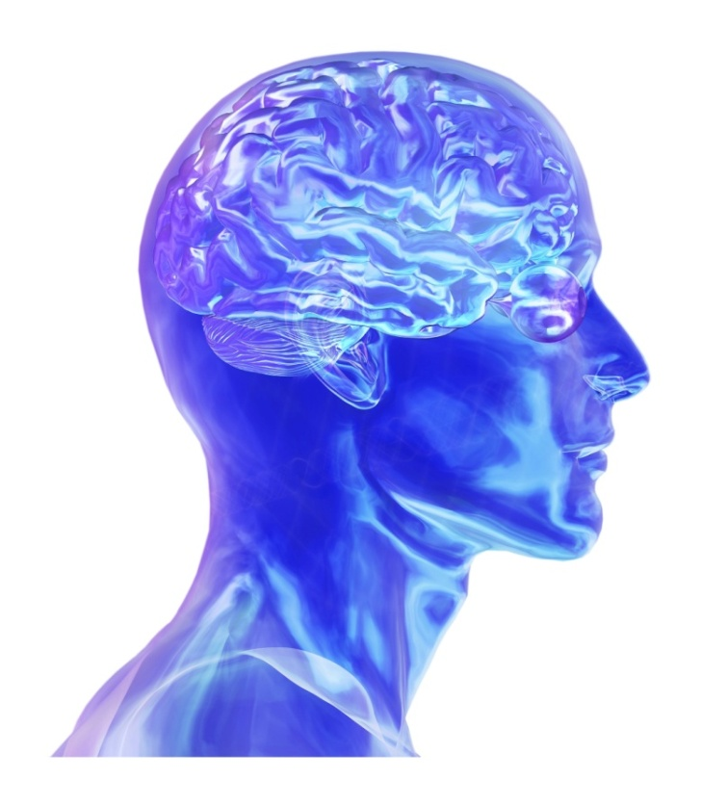
You must not neglect these organs, because keeping their functioning under control will ensure more stable glucose levels.

You must know that you are risking your life by avoiding looking for the right information.

The diabetes problem won’t fix itself, you must take action to find an early solution, or rather, an opportune time.

3. Expect That Medicines to Do All The Work.
There are a large number of products and medicines in the market focused on alleviating diabetics problems, however, far from improving, they worsen the situation.
This is because most of these drugs imply many undesirable side effects, for example, they can generate hypoglycemia, and even worse, also generate serious cardiovascular problems, without including other unpleasant symptoms such as the tendency to gain weight.
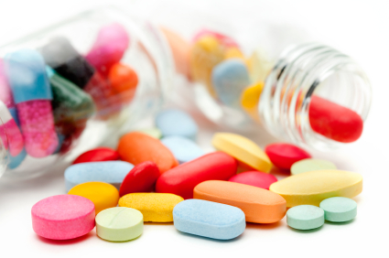
There are several known medications that fall into the category of dangerous, such as Avandia, Actos, Glyburide, Glipizide.

In fact, some of them are warned by the FDA, which reports that their consumption can lead to death.
Even if you take only one of these medications, you are at high risk of side effects.
But of course, if you take more than one, the complications probability is higher.

The question would be…
Why am I taking those medicines?

4. Be Careless With Food.
As a diabetic, a large part of maintaining a healthy life is based on feeding properly.
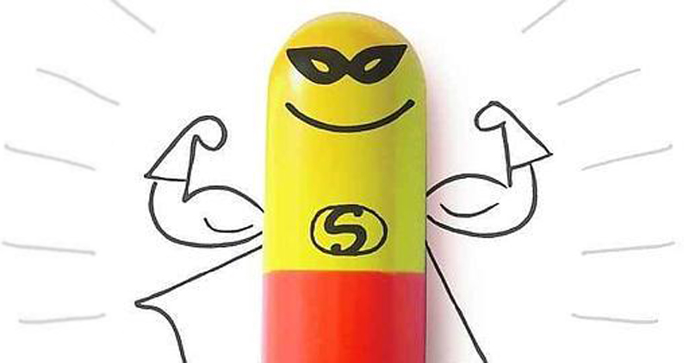
Unfortunately, when going to traditional doctors, they usually stuff the diabetic patient with drugs that eventually develop other problems. But it is not common a doctor recommending making changes in the diet or include vitamin supplements in the equation.
Some diabetics are persuaded by mysterious supplements that promise to cure diabetes easily and quickly, as “magic solutions”.

These are advertising tricks, well, diabetes cannot be cured by any magic pill.
Staying healthy being a diabetic patient requires more effort than simply taking a “miracle medicine”.

With regard to diet, most diabetics concentrate their efforts on not eating sugar, but you must go beyond that to give your body adequate nutrition.

5. Become Downcast by Diabetes.
This error can be even more harmful than side effects of the drugs, since the battle against diabetes has a high psychological level, which makes it a fight against yourself.
Being diagnosed as a diabetic doesn't mean that you need to suffer that burden for the rest of your life. And if you feel that every day your quality of life worsens, you should consider making a change.

A change from within and that is projected outside, towards others. You should be happy, healthy and free, to lead a full life.

You shouldn't let yourself be defeated by illness, you shouldn’t feel scared and sad. A negative attitude of that kind may affect your relationships, your work and all aspects related to your health.
If you feel that diabetes is causing you this kind of suffering, then you are losing a battle you can win!
All you have to do is to follow the required steps.


Type 2 Diabetes and Prediabetes
Are REVERSIBLE!

I assure you it is true, even though it may be difficult to believe at first, since, probably, your doctor has never told you something like this before.
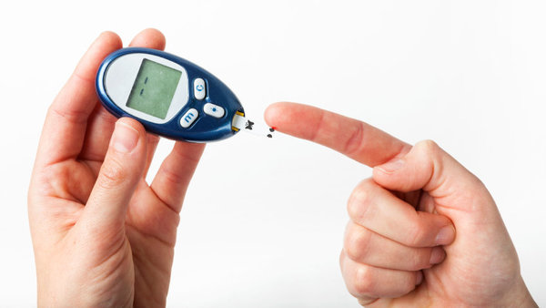
Many health professionals use to tell that diabetes is an irreversible condition to which you must get used to.
And the only thing you can do is control the disease with medicines, try to follow a diet and lose some weight to slow down its progression.
But this is not true. A see results on a daily basis which prove the opposite, that type 2 diabetes and prediabetes CAN be reversed.

And when a patient is committed and agrees to follow a step by step scheduled plan, there are very few cases when I have seen someone failing to achieve that goal.
I can understand you are skeptical, surely, for many years you have been listening to people telling you otherwise.
Surely, those professionals had the best intentions, but I assure you that they didn't have the correct information, because they were also deceived.
I only want to ask you to keep fighting, to open your mind and to put aside your disbelief.


There is no reason for you to keep suffering from this disease.

I can tell you that type 2 diabetes can be reversed because I see that people who follow this program:
- Can reduce their need and dependence on drugs and insulin.
- Can lower and stabilize their blood sugar level.
- Can give up their medications (with the supervision of their doctor).
- Lose weight, usually without exercise.
- Increase their energy levels.
- Reduce complications related to diabetes.

- Achieve to recover the clinical status of non-diabetics.

We know that there are medications that may treat life-threatening diseases, and of course it is not bad, but type 2 diabetes and prediabetes can be controlled and reversed without using of dangerous medications with unpleasant side effects.
You must choose which path to follow. And it is essential that you make that decision as soon as possible.
Diabetes complications are known to everyone: blindness, amputations, kidney failure, neuropathy, heart disease and many more.

If you are already experiencing any of these complications, you probably know how frustrating and frightening it is to be told there is nothing you can do.

If you have just been diagnosed with the disease, you may think that you have everything under control...
But I ask you please do not be overconfident, because diabetes is a disease that cannot be ignored.
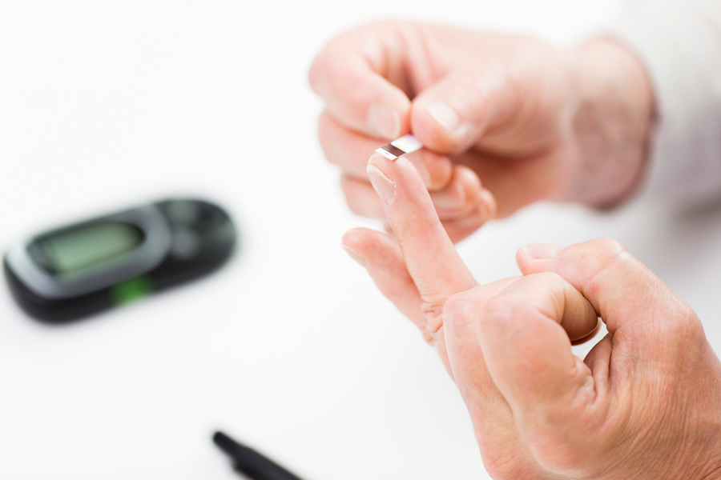
Don't wait until diabetes progresses to start taking care.
Not taking adequate measures to treat type 2 diabetes can be a death sentence.
Even if you are lucky and this disease doesn't reduce your life time in this world, even so, it will take your independence and your life quality.

Imagine the possibilities:
- No more dangerous drugs.
- No more insulin injections.
- Renewed energy.
- Controlled blood sugar
(without drugs or insulin).

- Lower diabetes complication or premature death risk.

To find the solution, you must know the cause. I can assure you that it isn't what you have been told, and it isn't what you think it is. When you find the root of the problem and you start to treat it, miracles happen.


If you are suffering from your diabetes, and you are prepared to be in charge of your health to completely reverse the disease, now is the time to regain your life and your freedom.
Access now for free to the information that will change your life forever. Click the link below.

The Truth About How to Reverse Your Type 2 Diabetes and Prediabetes

You deserve a full life, away from diabetes.

For your health!
Jefferson Matthews.

